SHAHAJIRAO PATIL VIKAS PRATISHTHAN
S.B.PATIL COLLEGE OF ENGINEERING,INDAPUR, DIST- PUNE.
DEPARTMENT OF CIVIL ENGINEERING
ACA-R-07 |  |  | CLASS TIME -TABLE |  |  |  |  | Academic Year : 2018-19
Rev : 01 |  |  |  |  |  |  |  | Semester : II
Date : 12.06.2015
Ref. SPVP/SBPCOE/CIVIL/2018-19/F-2/04 |  |  |  |  |  |  |  | Date : 06.02.2019
Class : B. E. |  |  |  |  |  |  |  | WEF:11.02.2019
Name of Class Teacher : Prof. Gawande U.S. |  |  |  |  |  | Class Room Location :215/17
 | Time/Day | 8.30 am to 9.30 am | 09.30 am to 10.30 am | 10.30 am to 11.30 pm | 11.30 am to 12.15 pm | 12.15 pm to 1.15 pm | 1.15 pm to 2.15 pm | 2.15 pm to 2.30 pm | 2.30 pm to 3.30 pm | 3.30 pm to 4.30 pm
 | MON | DHS | QSCT | TUTOR MEET |  | EL-III | DHS |  | EL-IV | LIB
 | TUE | EL-IV | DHS | EL-III |  | B1-CAD, B2-QSCT, B3-CAD |  |  | B1-EL-IV,B2-CAD,B3-CAD
 | WED | DHS | QSCT | EL-IV |  | B1-QSCT, B2-CAD, B3-DHS |  |  | QSCT | EL-III (NPTEL)
 | THU | QSCT | DHS | EL-IV |  | B1-DHS, B2-EL-III, B3-QSCT |  |  | B1-CAD,B2-EL-IV,B3-EL-III
 | FRI | EL-III | QSCT | EL-IV |  | B1-EL-III , B2-DHS, B3-EL-IV |  |  | PW | PW
 | SAT | PW | PW | PW |  | PW |  |  | PW | PW
ABBR Name of Subject |  |  | Name of Faculty |  |  |  | ABBR Name of Subject |  |  | Name of Faculty
DHS Dams and Hydo. Structures |  |  | Prof.Ms.Lawand M.S. |  |  |  | EL(IV) Construction Mgnt. Prof.SNT& Prof.GRB
QSCT Quantity Sur.,Cont. & Tenders |  |  | Prof. Sawant P.A. |  |  |  | Prof.SawantP.A.(PR)
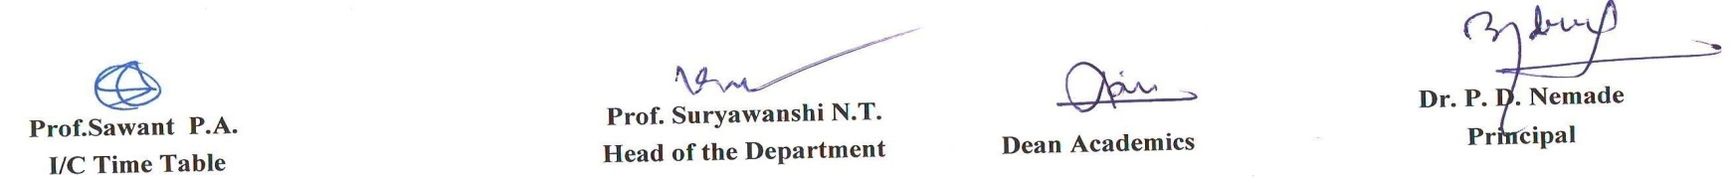  EL-III Hydropower Engg. |  |  | Prof. Gawande U.S./Katkar M.B.(PR) |  |  |  | PW Project Work

